**Course 3: Data Manipulation with pandas**

**Transforming DataFrames**

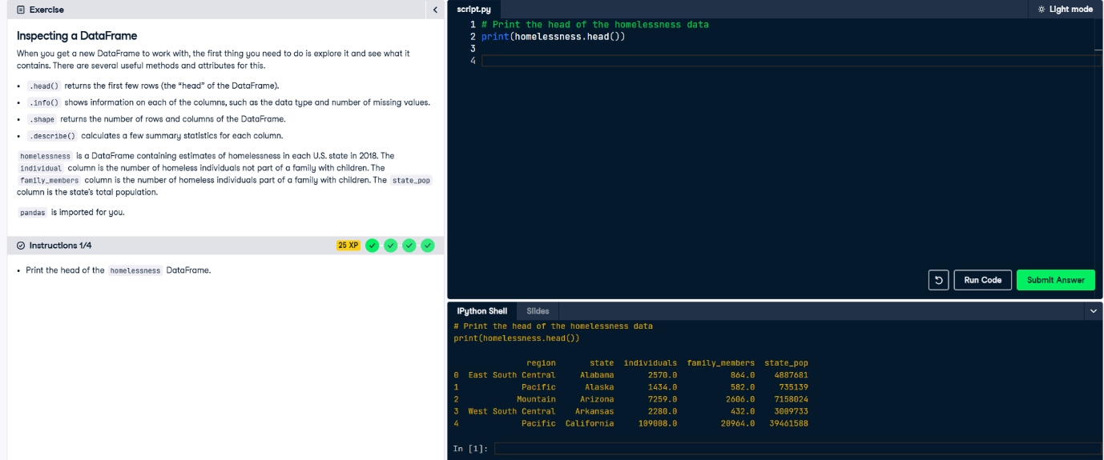 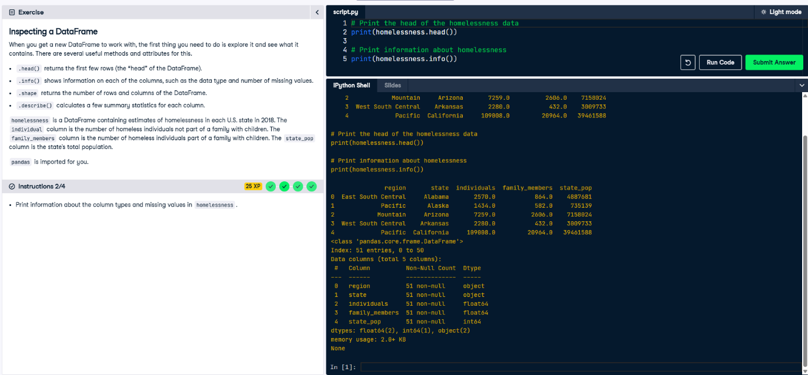 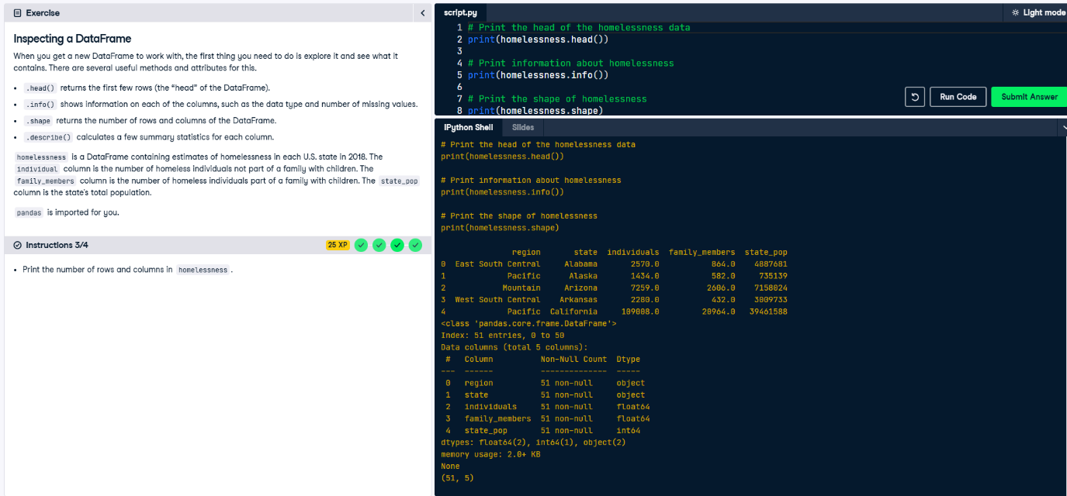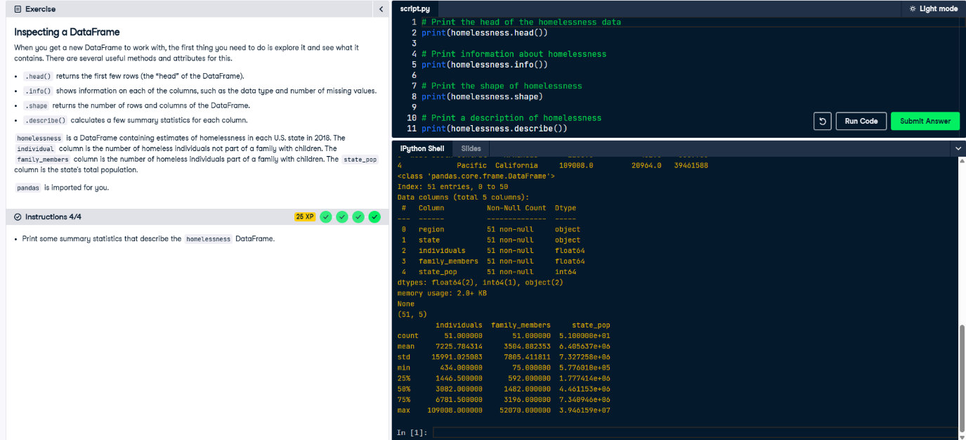 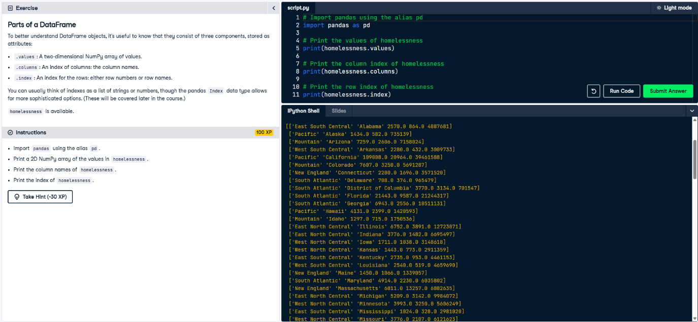

[['East South Central' 'Alabama' 2570.0 864.0 4887681]

['Pacific' 'Alaska' 1434.0 582.0 735139]

['Mountain' 'Arizona' 7259.0 2606.0 7158024]

['West South Central' 'Arkansas' 2280.0 432.0 3009733]

['Pacific' 'California' 109008.0 20964.0 39461588]

['Mountain' 'Colorado' 7607.0 3250.0 5691287]

['New England' 'Connecticut' 2280.0 1696.0 3571520]

['South Atlantic' 'Delaware' 708.0 374.0 965479]

['South Atlantic' 'District of Columbia' 3770.0 3134.0 701547]

['South Atlantic' 'Florida' 21443.0 9587.0 21244317]

['South Atlantic' 'Georgia' 6943.0 2556.0 10511131]

['Pacific' 'Hawaii' 4131.0 2399.0 1420593]

['Mountain' 'Idaho' 1297.0 715.0 1750536]

['East North Central' 'Illinois' 6752.0 3891.0 12723071]

['East North Central' 'Indiana' 3776.0 1482.0 6695497]

['West North Central' 'Iowa' 1711.0 1038.0 3148618]

['West North Central' 'Kansas' 1443.0 773.0 2911359]

['East South Central' 'Kentucky' 2735.0 953.0 4461153]

['West South Central' 'Louisiana' 2540.0 519.0 4659690]

['New England' 'Maine' 1450.0 1066.0 1339057]

['South Atlantic' 'Maryland' 4914.0 2230.0 6035802]

['New England' 'Massachusetts' 6811.0 13257.0 6882635]

['East North Central' 'Michigan' 5209.0 3142.0 9984072]

['West North Central' 'Minnesota' 3993.0 3250.0 5606249]

['East South Central' 'Mississippi' 1024.0 328.0 2981020]

['West North Central' 'Missouri' 3776.0 2107.0 6121623]

['Mountain' 'Montana' 983.0 422.0 1060665]

['West North Central' 'Nebraska' 1745.0 676.0 1925614]

['Mountain' 'Nevada' 7058.0 486.0 3027341]

['New England' 'New Hampshire' 835.0 615.0 1353465]

['Mid-Atlantic' 'New Jersey' 6048.0 3350.0 8886025]

['Mountain' 'New Mexico' 1949.0 602.0 2092741]

['Mid-Atlantic' 'New York' 39827.0 52070.0 19530351]

['South Atlantic' 'North Carolina' 6451.0 2817.0 10381615]

['West North Central' 'North Dakota' 467.0 75.0 758080]

['East North Central' 'Ohio' 6929.0 3320.0 11676341]

['West South Central' 'Oklahoma' 2823.0 1048.0 3940235]

['Pacific' 'Oregon' 11139.0 3337.0 4181886]

['Mid-Atlantic' 'Pennsylvania' 8163.0 5349.0 12800922]

['New England' 'Rhode Island' 747.0 354.0 1058287]

['South Atlantic' 'South Carolina' 3082.0 851.0 5084156]

['West North Central' 'South Dakota' 836.0 323.0 878698]

['East South Central' 'Tennessee' 6139.0 1744.0 6771631]

['West South Central' 'Texas' 19199.0 6111.0 28628666]

['Mountain' 'Utah' 1904.0 972.0 3153550]

['New England' 'Vermont' 780.0 511.0 624358]

['South Atlantic' 'Virginia' 3928.0 2047.0 8501286]

['Pacific' 'Washington' 16424.0 5880.0 7523869]

['South Atlantic' 'West Virginia' 1021.0 222.0 1804291]

['East North Central' 'Wisconsin' 2740.0 2167.0 5807406]

['Mountain' 'Wyoming' 434.0 205.0 577601]]

Index(['region', 'state', 'individuals', 'family_members', 'state_pop'], dtype='object')

Index([ 0, 1, 2, 3, 4, 5, 6, 7, 8, 9, 10, 11, 12, 13, 14, 15, 16, 17,

18, 19, 20, 21, 22, 23, 24, 25, 26, 27, 28, 29, 30, 31, 32, 33, 34, 35,

36, 37, 38, 39, 40, 41, 42, 43, 44, 45, 46, 47, 48, 49, 50],

dtype='int64')

<script.py> output:

[['East South Central' 'Alabama' 2570.0 864.0 4887681]

['Pacific' 'Alaska' 1434.0 582.0 735139]

['Mountain' 'Arizona' 7259.0 2606.0 7158024]

['West South Central' 'Arkansas' 2280.0 432.0 3009733]

['Pacific' 'California' 109008.0 20964.0 39461588]

['Mountain' 'Colorado' 7607.0 3250.0 5691287]

['New England' 'Connecticut' 2280.0 1696.0 3571520]

['South Atlantic' 'Delaware' 708.0 374.0 965479]

['South Atlantic' 'District of Columbia' 3770.0 3134.0 701547]

['South Atlantic' 'Florida' 21443.0 9587.0 21244317]

['South Atlantic' 'Georgia' 6943.0 2556.0 10511131]

['Pacific' 'Hawaii' 4131.0 2399.0 1420593]

['Mountain' 'Idaho' 1297.0 715.0 1750536]

['East North Central' 'Illinois' 6752.0 3891.0 12723071]

['East North Central' 'Indiana' 3776.0 1482.0 6695497]

['West North Central' 'Iowa' 1711.0 1038.0 3148618]

['West North Central' 'Kansas' 1443.0 773.0 2911359]

['East South Central' 'Kentucky' 2735.0 953.0 4461153]

['West South Central' 'Louisiana' 2540.0 519.0 4659690]

['New England' 'Maine' 1450.0 1066.0 1339057]

['South Atlantic' 'Maryland' 4914.0 2230.0 6035802]

['New England' 'Massachusetts' 6811.0 13257.0 6882635]

['East North Central' 'Michigan' 5209.0 3142.0 9984072]

['West North Central' 'Minnesota' 3993.0 3250.0 5606249]

['East South Central' 'Mississippi' 1024.0 328.0 2981020]

['West North Central' 'Missouri' 3776.0 2107.0 6121623]

['Mountain' 'Montana' 983.0 422.0 1060665]

['West North Central' 'Nebraska' 1745.0 676.0 1925614]

['Mountain' 'Nevada' 7058.0 486.0 3027341]

['New England' 'New Hampshire' 835.0 615.0 1353465]

['Mid-Atlantic' 'New Jersey' 6048.0 3350.0 8886025]

['Mountain' 'New Mexico' 1949.0 602.0 2092741]

['Mid-Atlantic' 'New York' 39827.0 52070.0 19530351]

['South Atlantic' 'North Carolina' 6451.0 2817.0 10381615]

['West North Central' 'North Dakota' 467.0 75.0 758080]

['East North Central' 'Ohio' 6929.0 3320.0 11676341]

['West South Central' 'Oklahoma' 2823.0 1048.0 3940235]

['Pacific' 'Oregon' 11139.0 3337.0 4181886]

['Mid-Atlantic' 'Pennsylvania' 8163.0 5349.0 12800922]

['New England' 'Rhode Island' 747.0 354.0 1058287]

['South Atlantic' 'South Carolina' 3082.0 851.0 5084156]

['West North Central' 'South Dakota' 836.0 323.0 878698]

['East South Central' 'Tennessee' 6139.0 1744.0 6771631]

['West South Central' 'Texas' 19199.0 6111.0 28628666]

['Mountain' 'Utah' 1904.0 972.0 3153550]

['New England' 'Vermont' 780.0 511.0 624358]

['South Atlantic' 'Virginia' 3928.0 2047.0 8501286]

['Pacific' 'Washington' 16424.0 5880.0 7523869]

['South Atlantic' 'West Virginia' 1021.0 222.0 1804291]

['East North Central' 'Wisconsin' 2740.0 2167.0 5807406]

['Mountain' 'Wyoming' 434.0 205.0 577601]]

Index(['region', 'state', 'individuals', 'family_members', 'state_pop'], dtype='object')

Index([ 0, 1, 2, 3, 4, 5, 6, 7, 8, 9, 10, 11, 12, 13, 14, 15, 16, 17,

18, 19, 20, 21, 22, 23, 24, 25, 26, 27, 28, 29, 30, 31, 32, 33, 34, 35,

36, 37, 38, 39, 40, 41, 42, 43, 44, 45, 46, 47, 48, 49, 50],

dtype='int64')

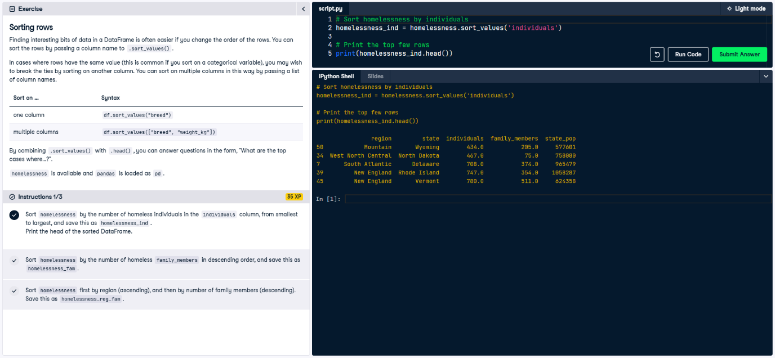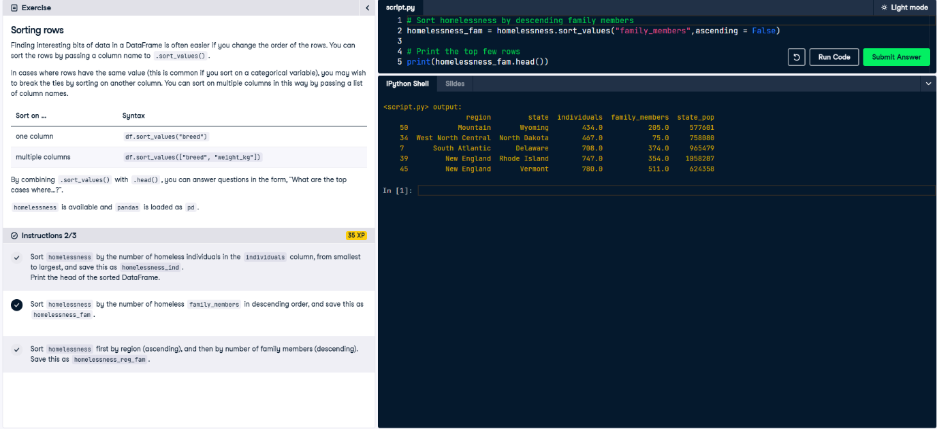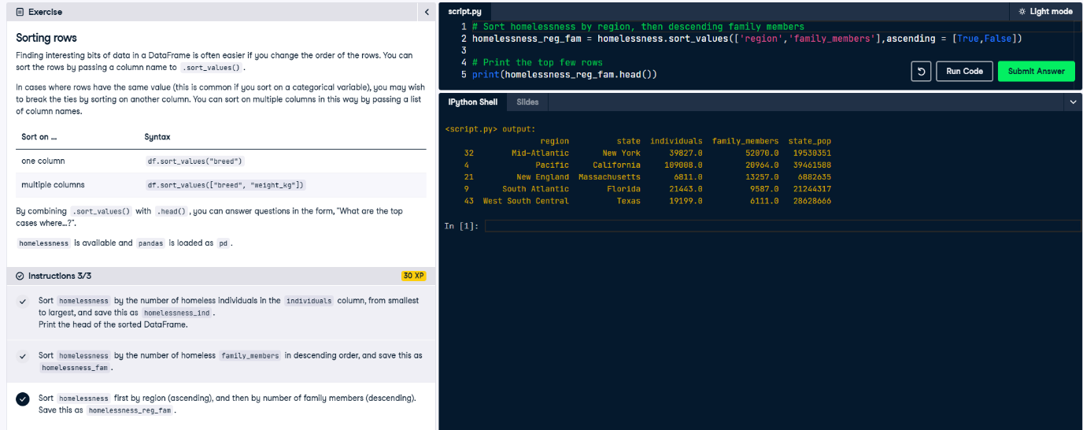

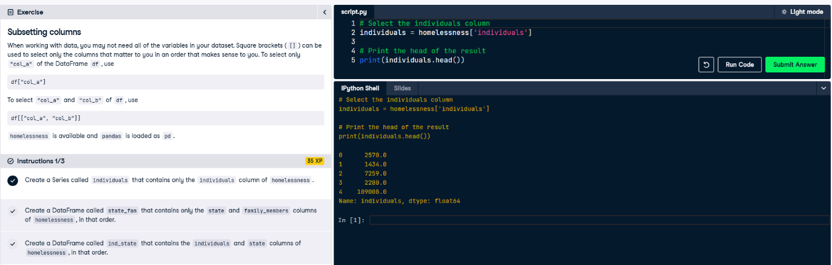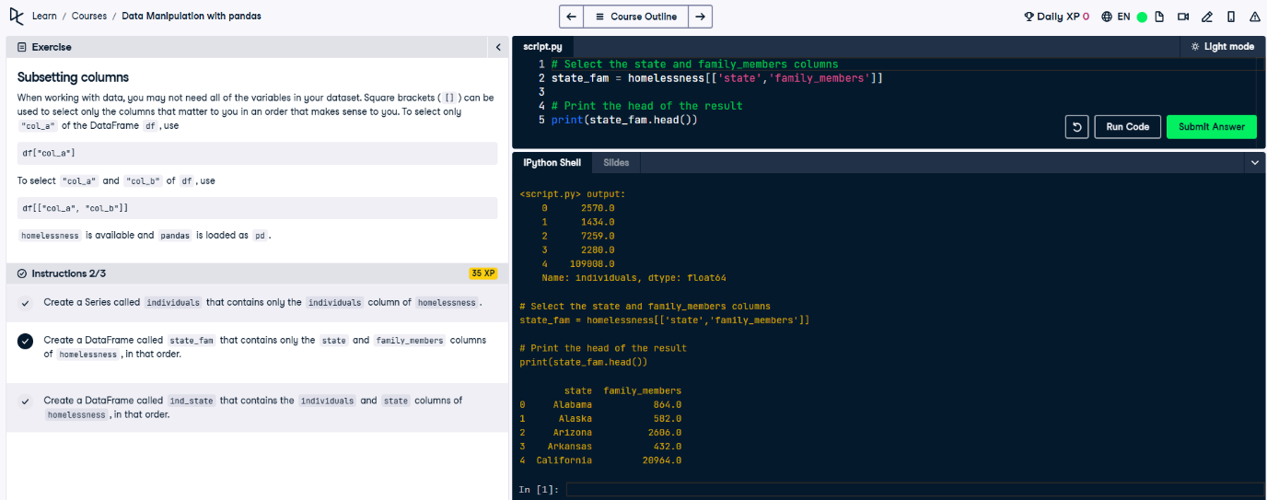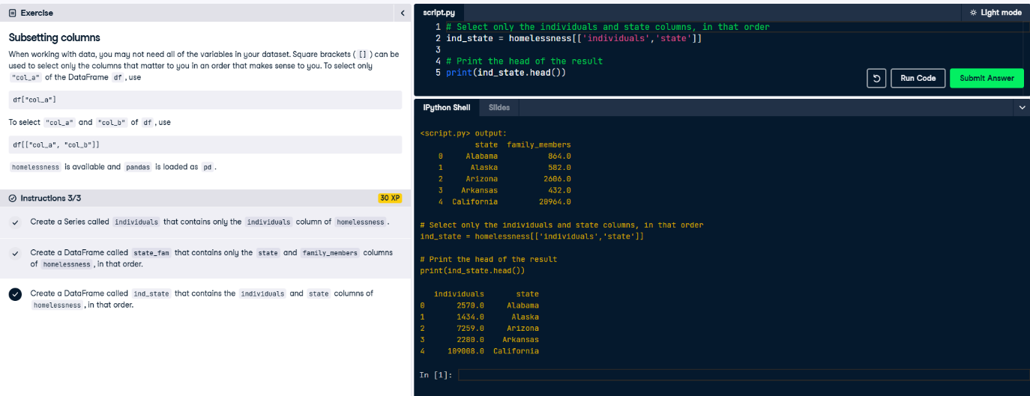

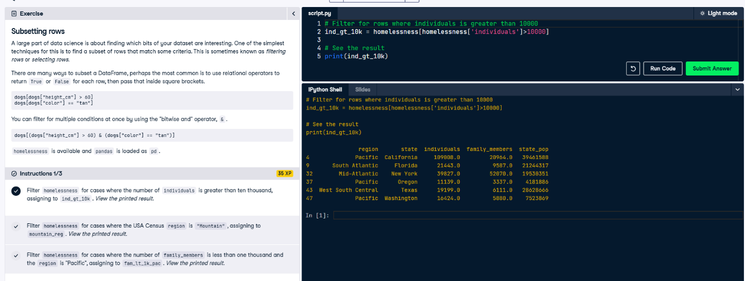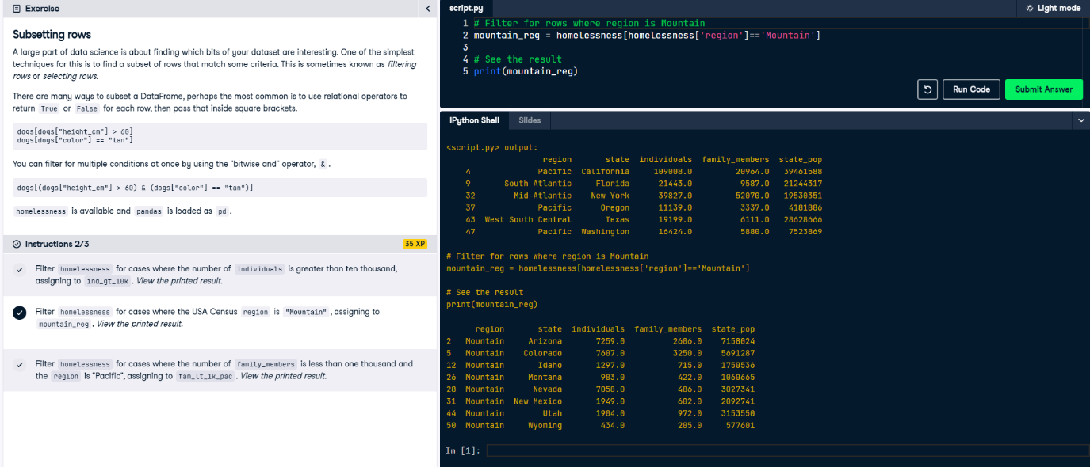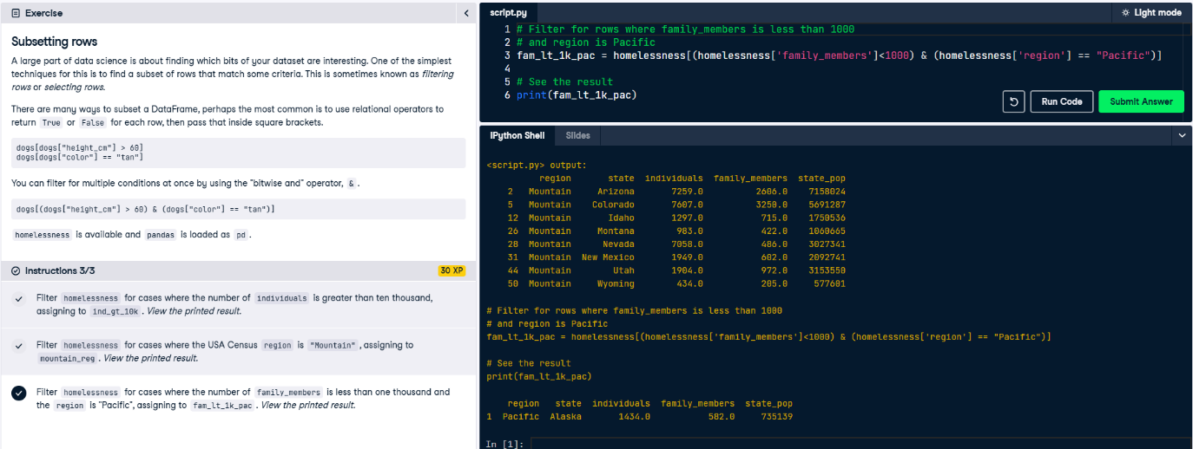

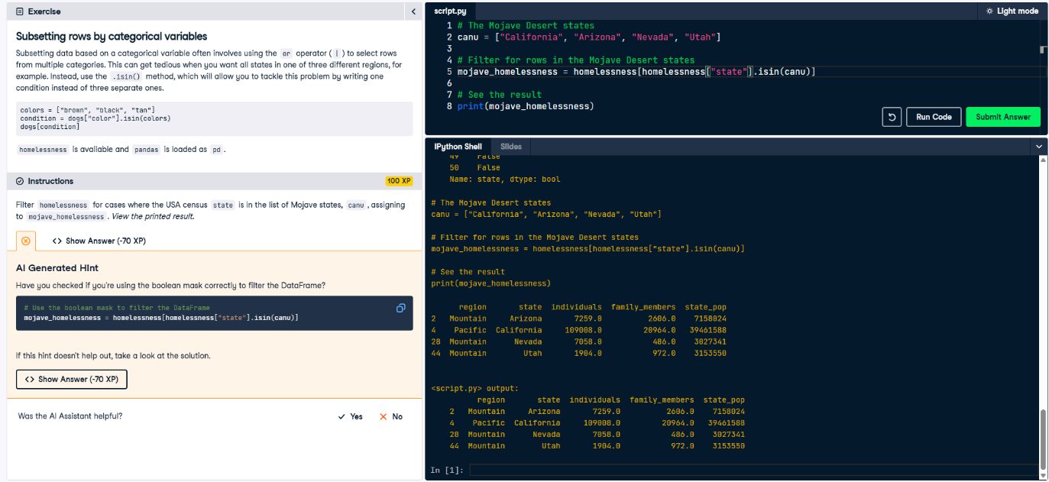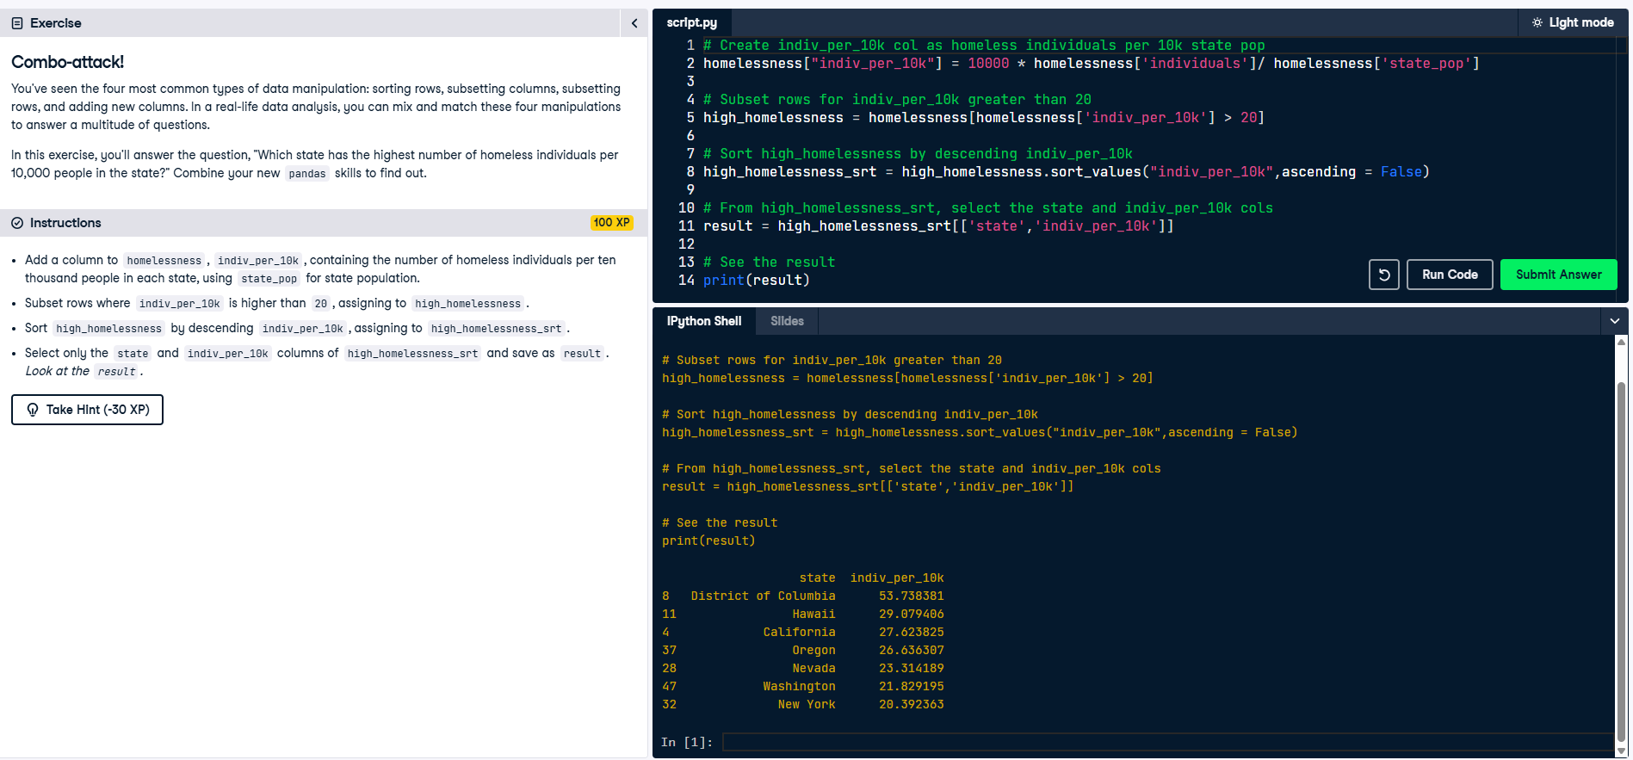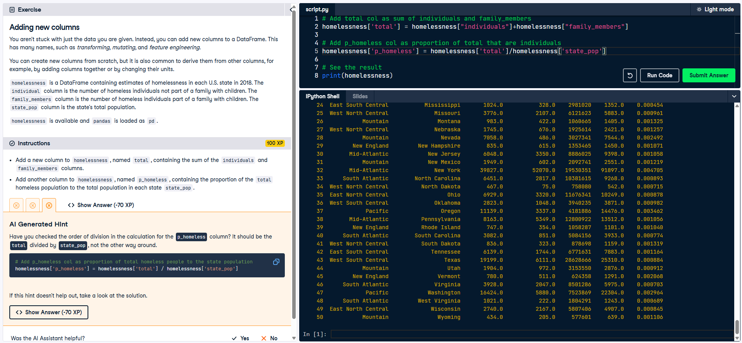

**Aggregating DataFrames**

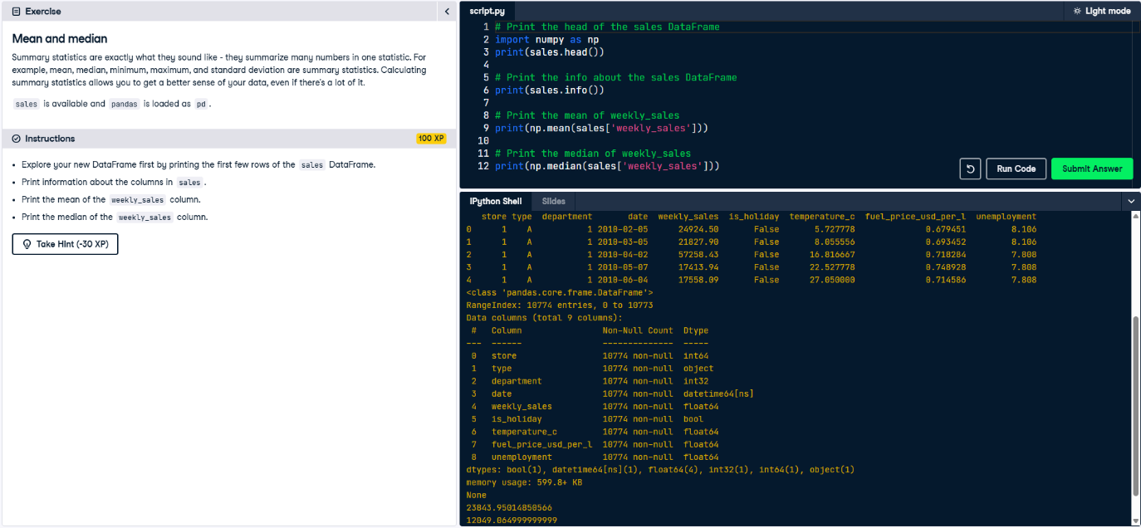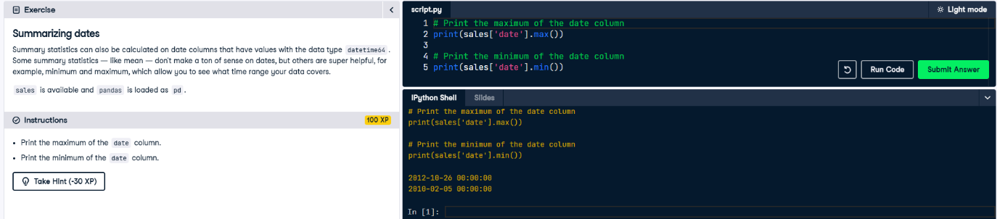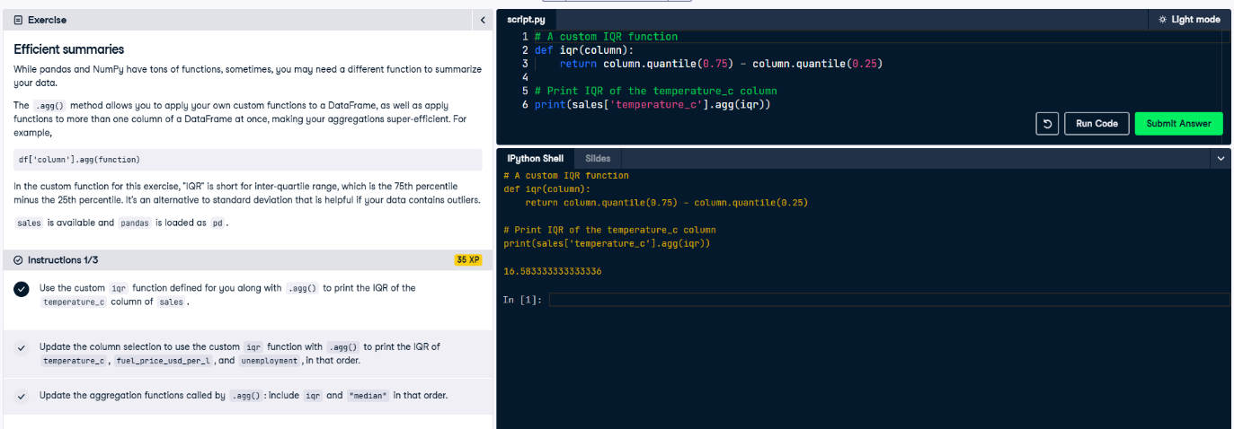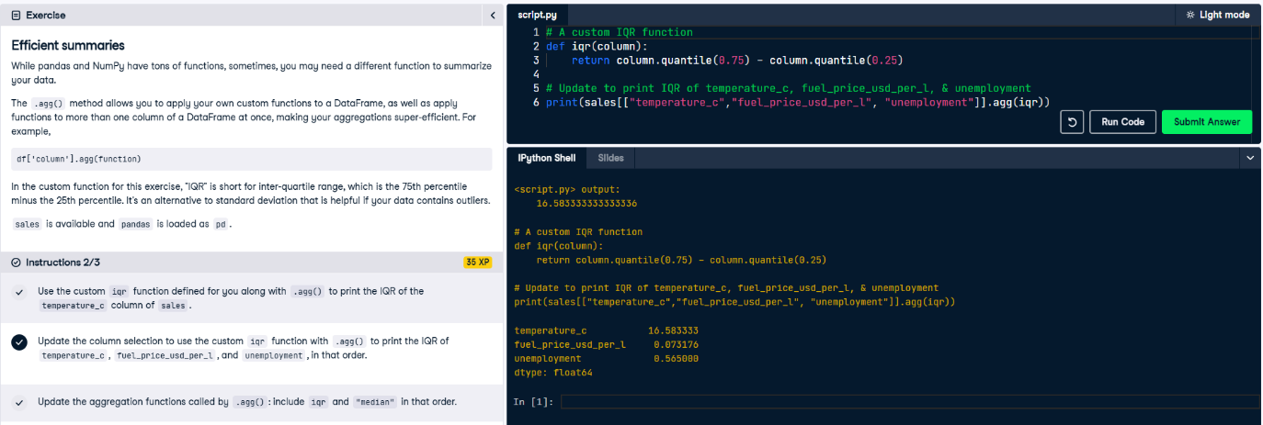

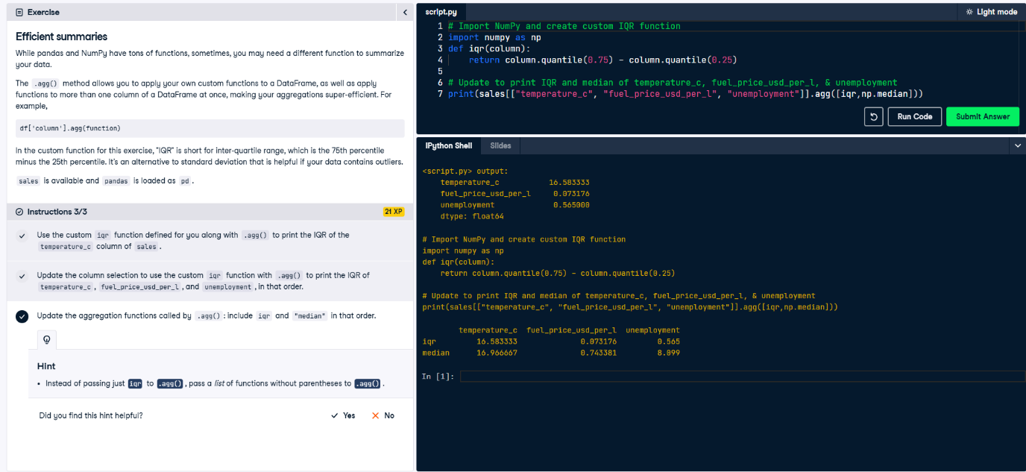

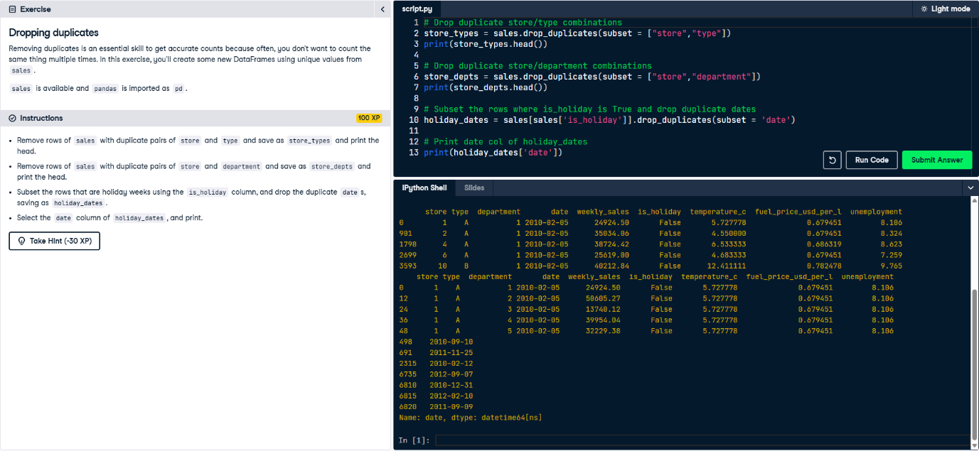

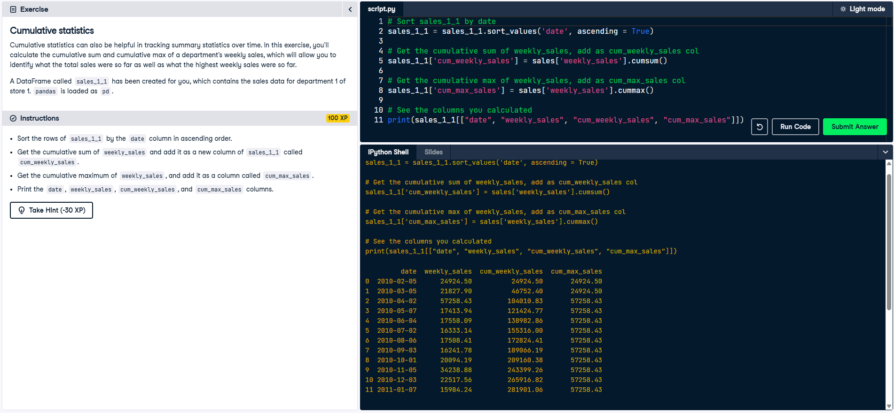

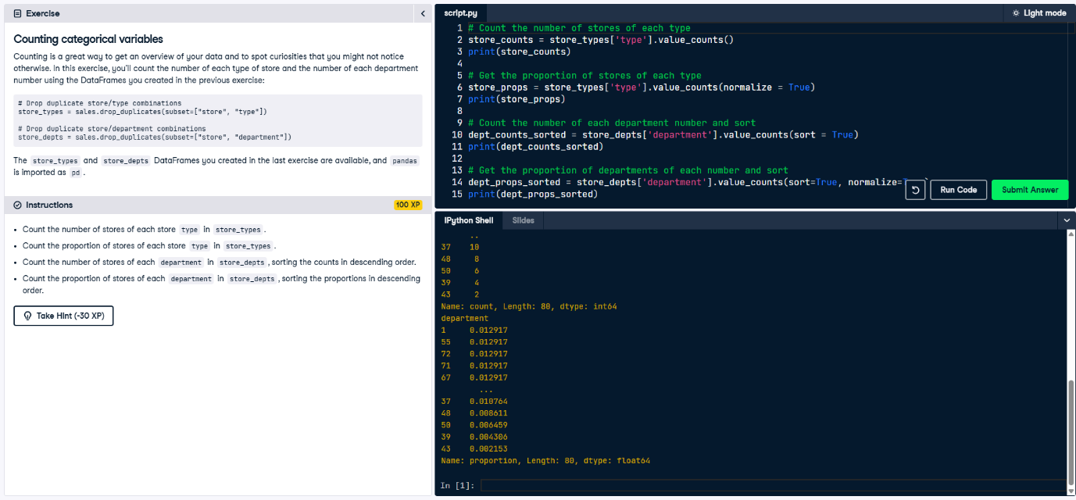

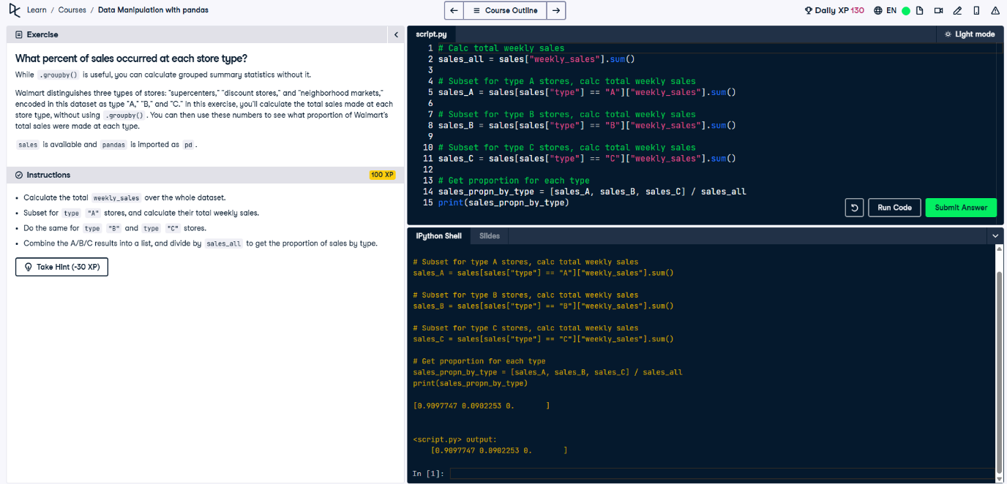

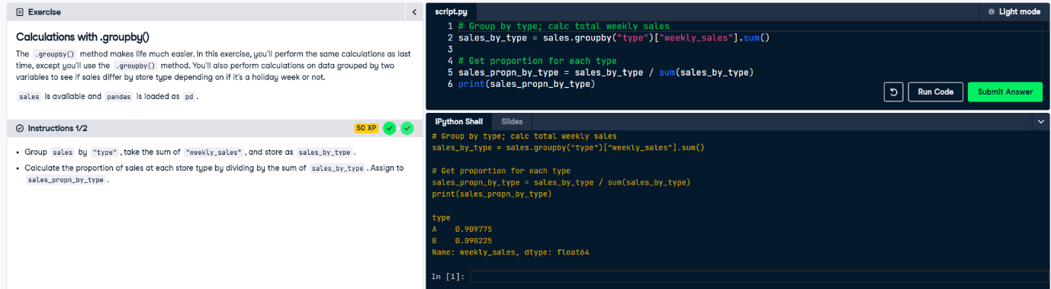

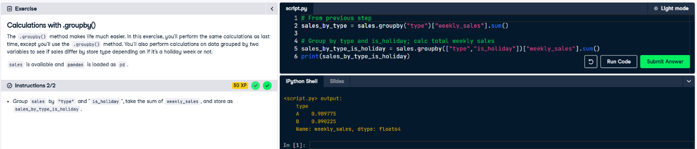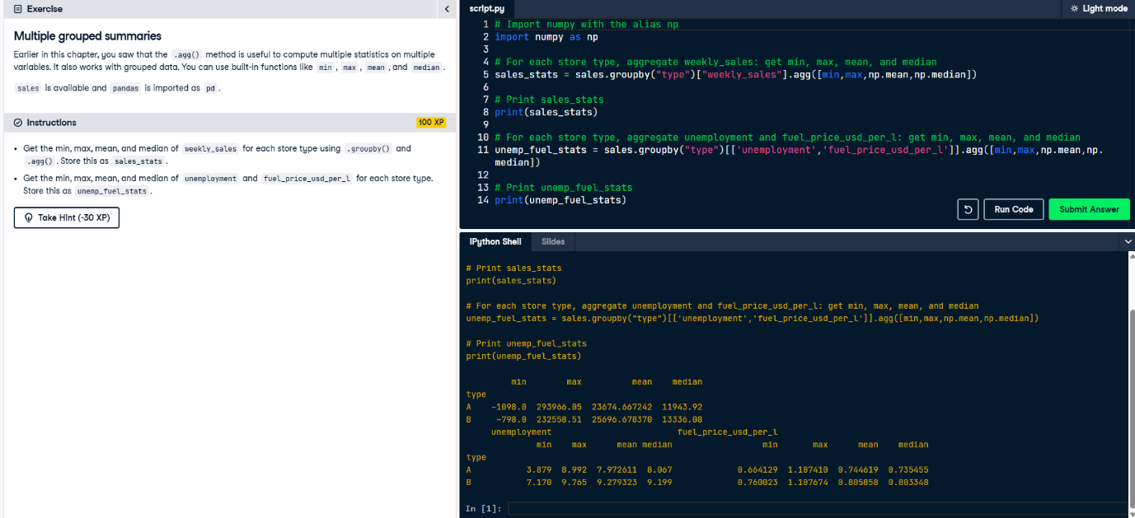

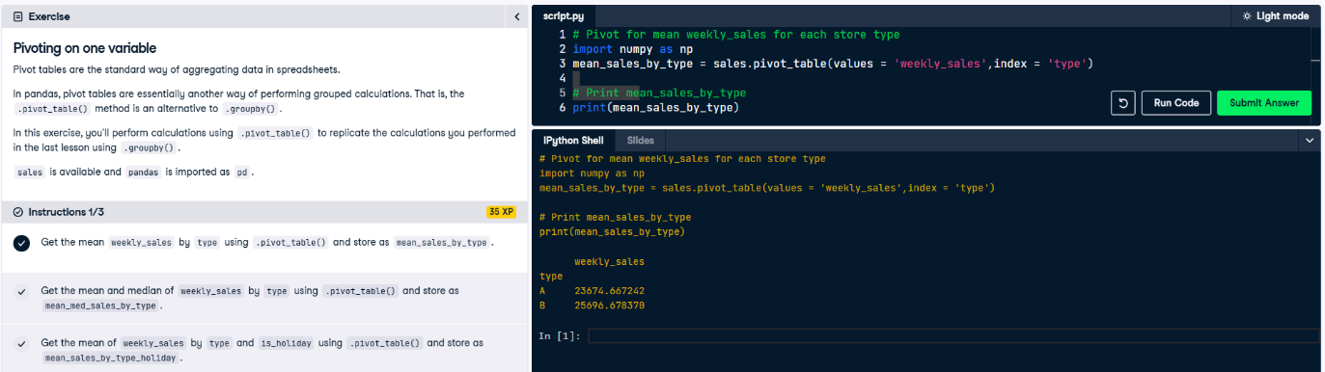

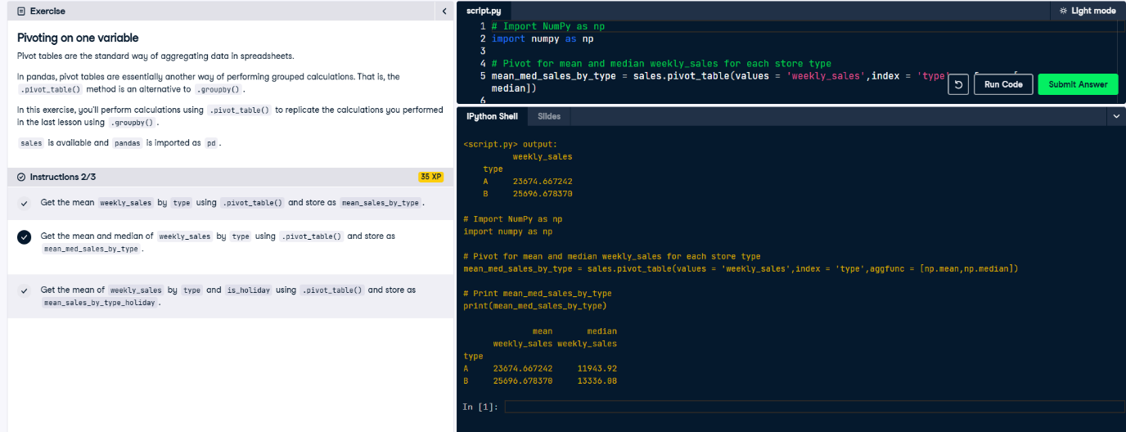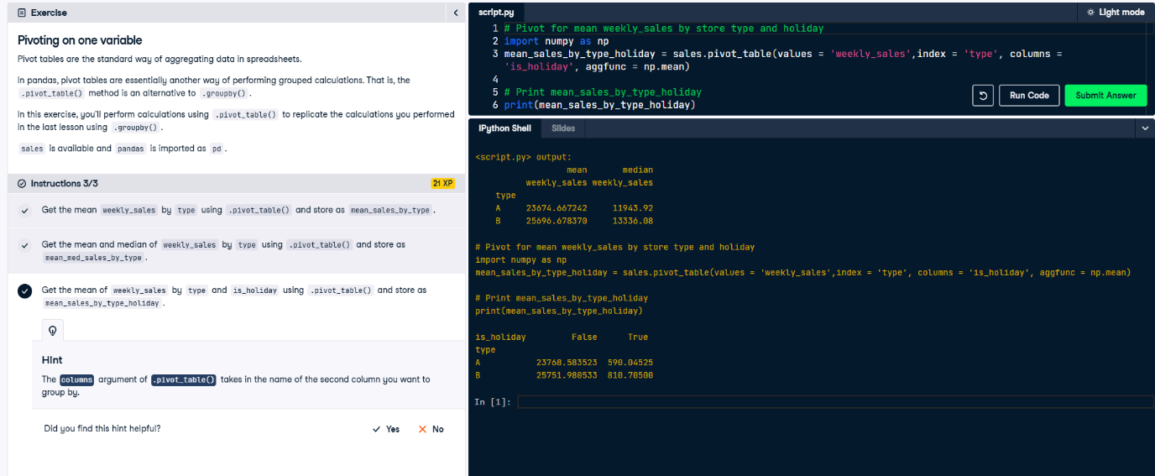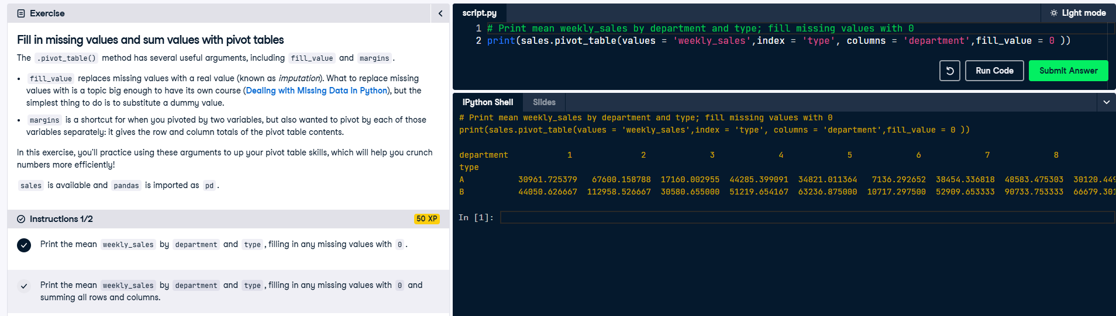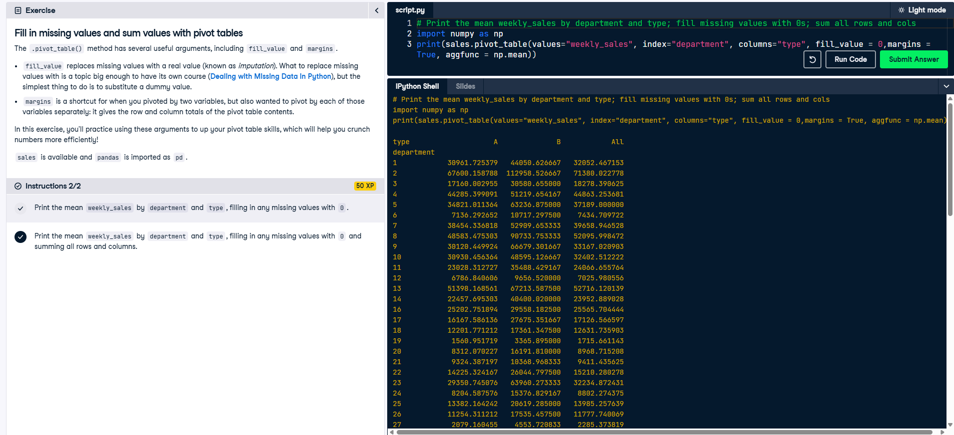

**Slicing and Indexing DataFrames**

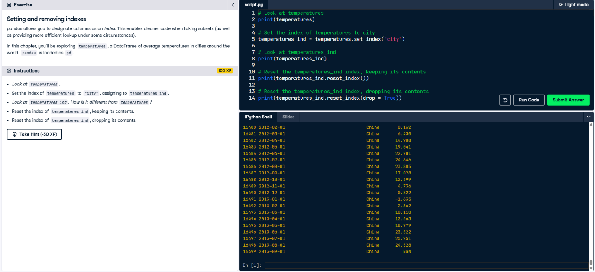

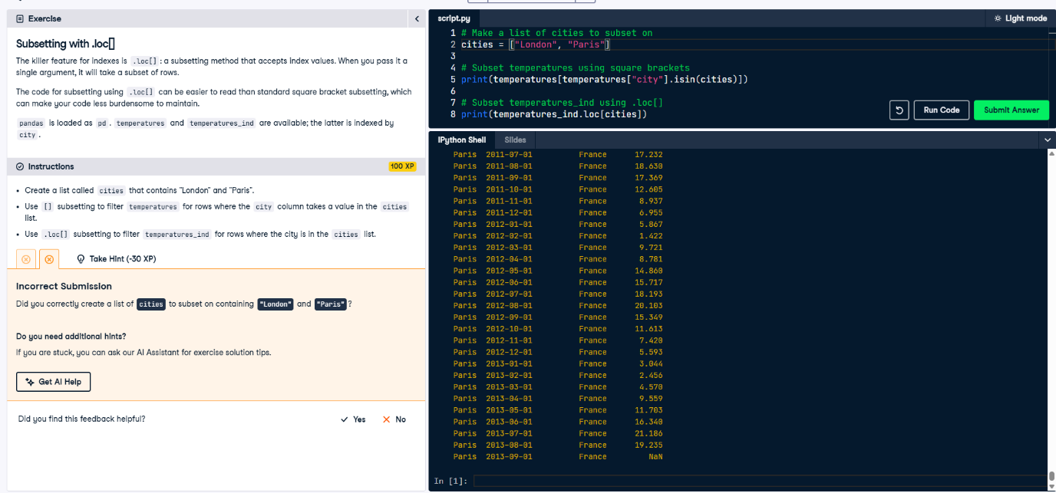

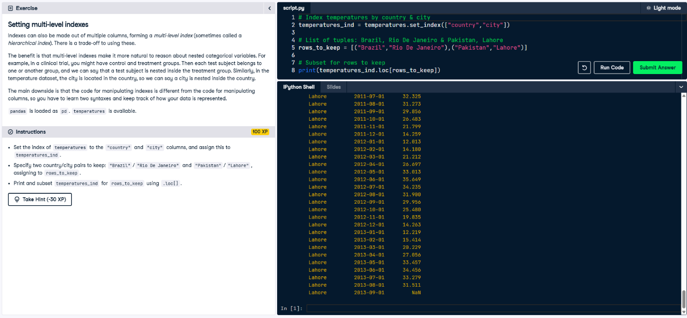

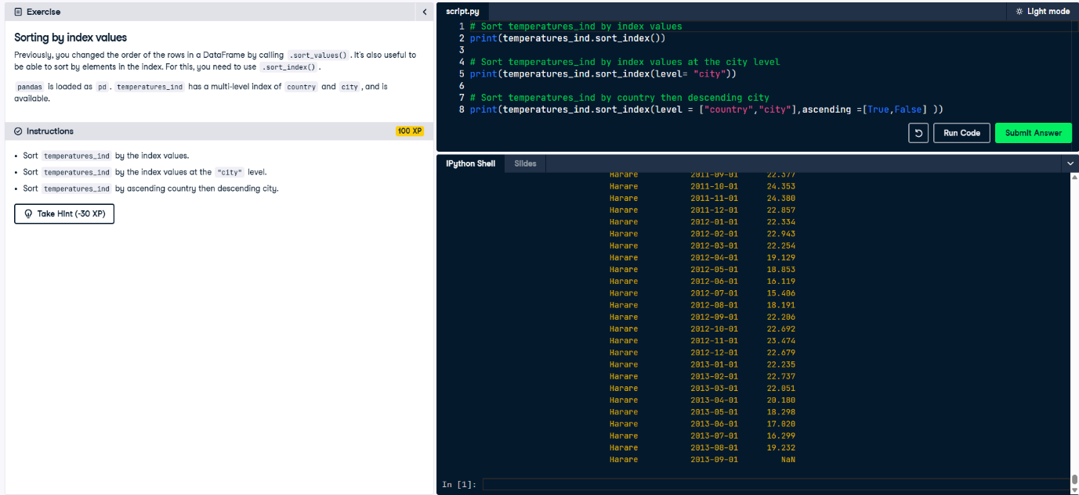

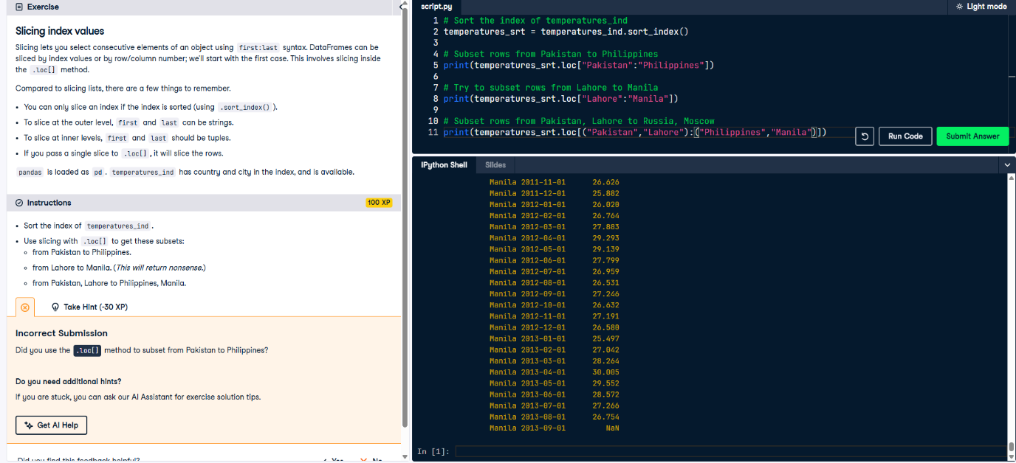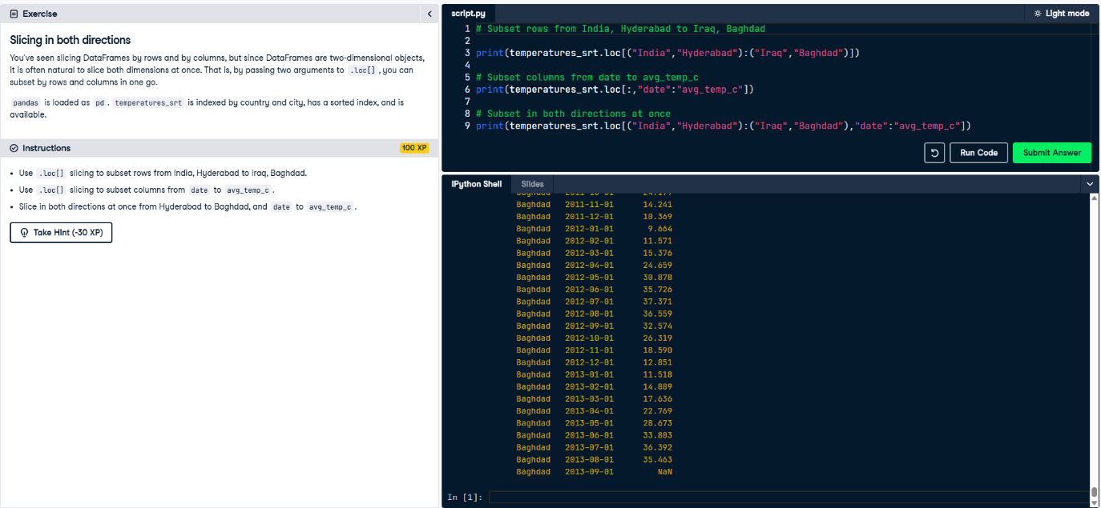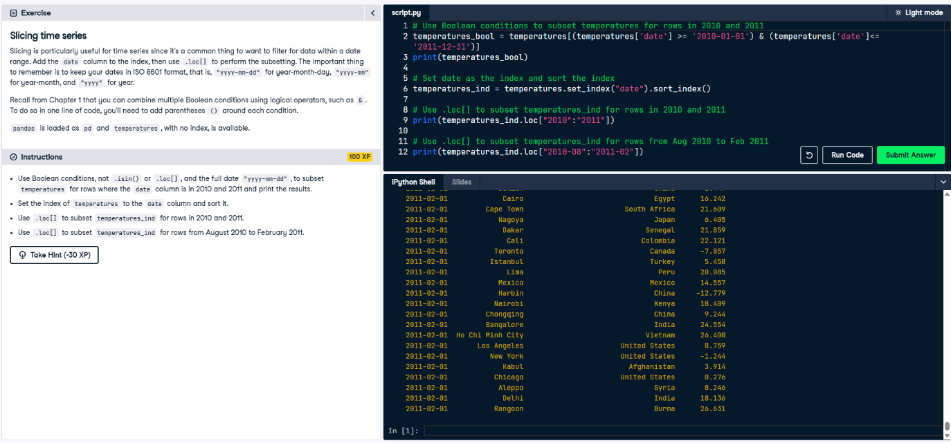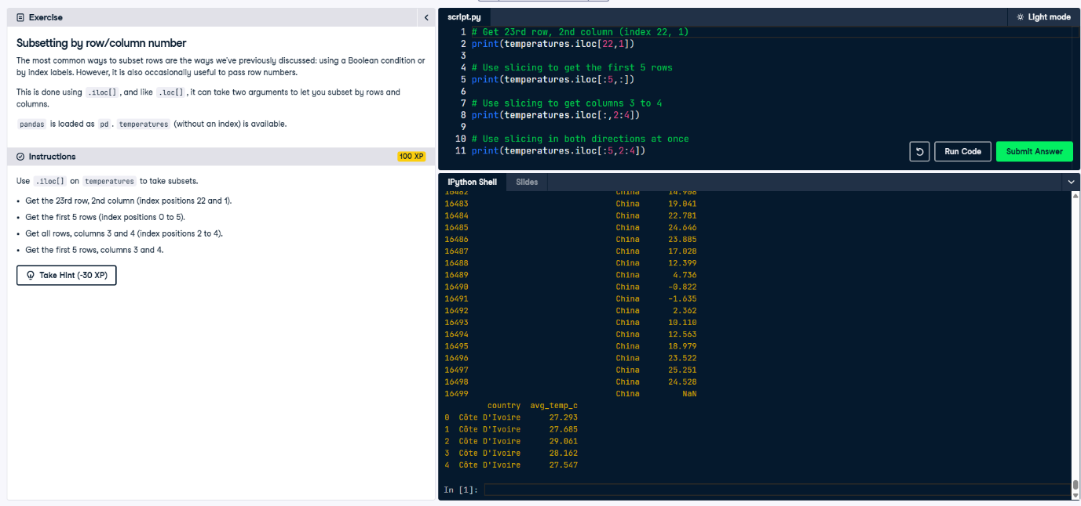

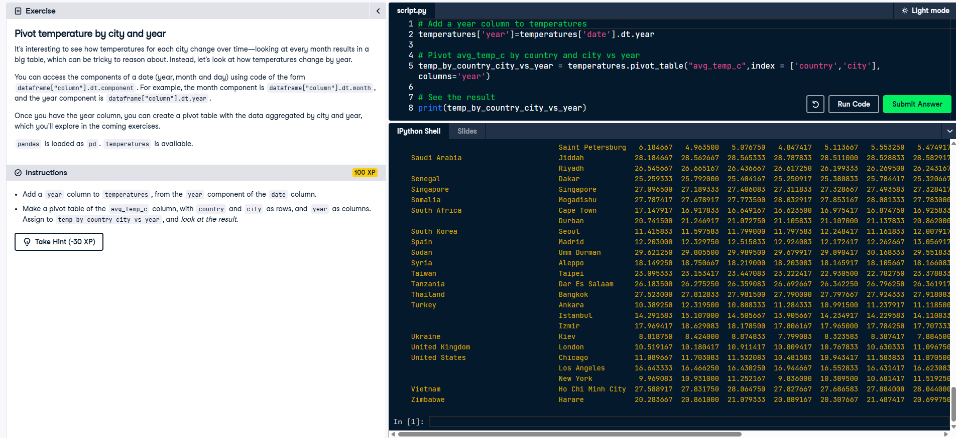

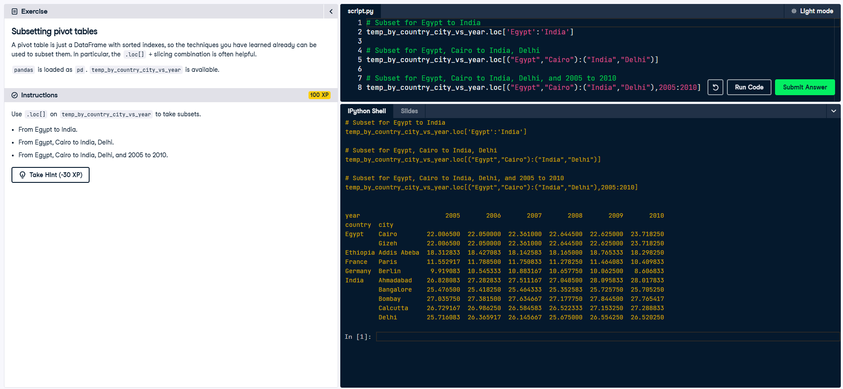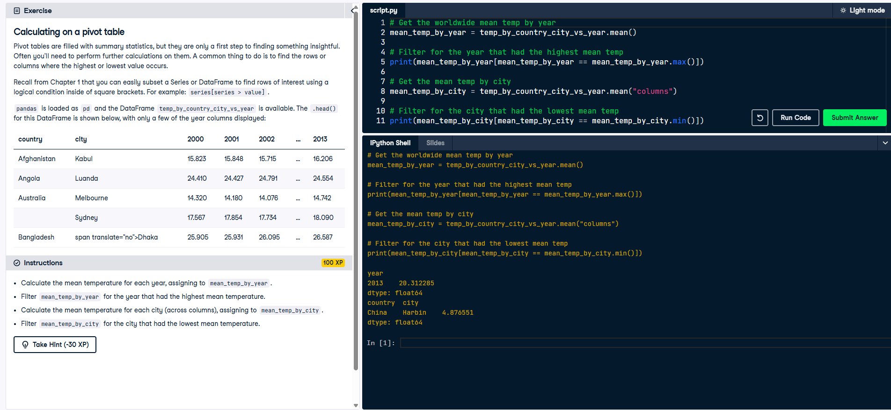

**Creating and Visualizing DataFrames**

